TITLE PAGE

**Table of Contents**

Abstract 1

Introduction 1

Chapter 1 Overview on X-ray detection 1

1.1 Sources of characteristic X-rays 1

1.2 Interaction mechanisms of X-rays with matter 2

1.3 X-ray tube 5

1.4 Inorganic semiconducting materials for X-ray detection 8

Chapter 2 Thin-film X-ray detectors based on organic semiconductors and transition metal dichalcogenides 15

2.1 Device architecture of thin-film X-ray detectors 15

2.2 Electrical characteristics of a Field Effect Transistor (FET) 16

2.2.1 Transfer and output characteristics of a FET 17

2.3 X-ray detection mechanism for thin-film X-ray detectors 20

2.3.1 Charge collection and Photoconductive gain 21

2.4 Sensitivity 23

2.5 Examples of sensitivity of some organic and hybrid semiconductors 25

2.6 Overview on X-ray detectors based on TMTES:PS 26

2.7 Overview on TMDC 31

2.7.1 Electrical properties of monolayer MoS2 32

2.7.2 Fabrication methods of 1L-MoS2 33

2.7.3 Overview on the performance of 1L-MoS2 direct X-ray detectors 37

Chapter 3 Experimental Methods 39

3.1 MoS2 Samples 39

3.1.1 Fabrication methods 39

3.1.2 IV characterization 40

3.1.3 Characterization under X-rays 40

3.2 TMTES:PS Samples 40

3.2.1 Fabrication methods 40

3.2.2 IV characterization 40

3.2.3 Characterization under X-rays 40

Chapter 4 Results for MoS2 samples 40

Chapter 5 Results for TMTES:PS samples 40

Chapter 6 Conclusions 40

Bibliography 40

# Abstract

Here is the abstract…

# Introduction

This is the Introduction part. Here I include the topic of the thesis, brief description of innovative materials, the goal of the thesis – to understand and to compare two performances of the devices with similar structures, the structure of the thesis.

# Overview on X-ray detection

PASTE FROM THE CORRECTRED VERSION

# Thin-film X-ray detectors based on organic semiconductors and transition metal dichalcogenides

In previous chapter I provided a general overview on X-rays and their interaction with matter. Besides, conventional X-ray detectors based on inorganic semiconductors were briefly discussed. This chapter represents thin-film X-ray detectors, which are based on organic semiconductors and transition metal dichalcogenides (TMDCs). First, I will discuss basic device architectures of the detectors, such as a photodiode and a phototransistor. Since the phototransistor structure was actually used in the experimental part of my research, a detailed overview on a thin-film field effect transistor and its electrical properties will also be provided.

Once the device architecture is presented, an important direct X-ray detection mechanism – photoconductive gain, will be described. This mechanism is of particular interest, since it greatly enhances the sensitivity of low-*Z* organic semiconductors, which makes them comparable alternative to sensors based on inorganic semiconductors. Finally, I will analyze concrete semiconducting materials – 2D MoS2 thin films and a novel organic semiconductor denoted as TMTES blended with polystyrene, which were examined as absorber materials for X-ray detection in my research.

## Device architecture of thin-film X-ray detectors

Nowadays thin-film X-ray detectors constitute the domain that is still quite poorly studied. Different semiconducting materials are being examined to integrate in the X-ray detectors before their further pixelization into large-scale X-ray sensors. For this purpose, in order not to focus on the device configuration but rather on the material properties, basic thin-film photodetector structures are used, in which the semiconductor medium (also called as *absorbing layer* or *active channel*) is operated. Such architectures can be classified as photoconductors, photodiodes and phototransistors. Each architecture has its own different variations depending on the layer and electrode structure. In particular, the geometry of the photodetectors can be either *vertical* or *co-planar* (Laura Basiricò A. C., 2021). In the vertical geometry the absorbing layer is sandwiched between two electrodes, whereas in the co-planar geometry the absorbing layer is directly exposed to the incident radiation. While the vertical geometry is convenient to use in a pixelated matrix, the latter one is easier to fabricate and does not depend on the thickness of the active channel.

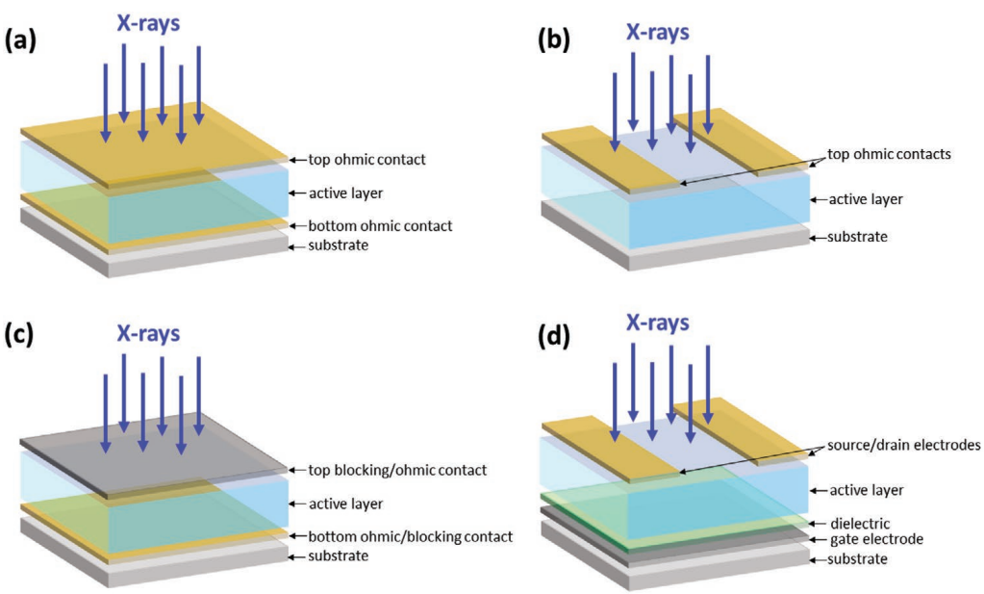

Figure 2.1 Schematics of four typical architectures for direct X-ray detectors: (a) Vertical photoconductor architecture; (b) co-planar photoconductor architecture; (c) photodiode architecture; (d) phototransistor architecture ( (Laura Basiricò A. C., 2021).

A photodiode is vastly used, since its architecture is based on a well-known reverse biased *pn*-junction, which minimizes dark current increasing the signal-to-noise ratio. A phototransistor represents more complex structure, however, it provides more freedom to tune the detector properties and to optimize them for specific conditions. Specifically, by biasing the gate electrode with voltage above the threshold value, it is possible to increase the charge carrier density in the active channel, which will enhance its performance due to so-called *photoconductive gain* mechanism, which will be discussed in the next sections. Furthermore, by applying the gate voltage under its threshold value, a phototransistor will behave as a photodiode performing the *charge separation* mechanism. (Laura Basiricò A. C., 2021).

## Electrical characteristics of a Field Effect Transistor (FET)

Before discussing the X-ray detection mechanisms in the active channel of a phototransistor, it is important to first know the main electrical properties of a field effect transistor (FET), on which a phototransistor is based on. The working principle of a FET lies in the creation of a conductive layer (called the *hole* or *electron inversion layer* for *n-* or *p-*type semiconductor, respectively) between the *source* and *drain* electrodes by applying an electric field between the active channel and the *gate* electrode separated by an insulator (Fig.2.2). Usually, the source electrode is referred to ground, thus, the gate voltage can sometimes be denoted as the gate-source voltage or *VGS*. This is called the *common source configuration* (Luisa Torsi, 2013). The channel length *L* is the distance between the source and drain pads and the channel width *W* is the geometrical width of the channel.

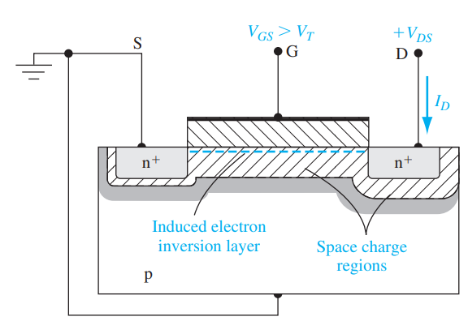

Figure 2.2 Schematics of a FET based on a *p*-type semiconductor. At *VGS­* exceeding certain threshold voltage *Vth*an electron inversion channel is induced and the current of from drain to source flows (Neamen, 2012).

A FET is operated by switching between two modes. The *depletion* mode (OFF state) is the state, in which the inversion layer is absent, thus, the active channel is highly resistive and the current *IDS* between the drain and source is nearly zero (the contribution is only due to small leakage current through the insulator and thermally induced current between drain and source). The *accumulation* (Luisa Torsi, 2013)mode (ON state) is the state, in which the inversion conductive layer is formed, thus, *IDS* starts to increase. The larger |*VGS*| is, the larger the accumulated charge density will be and thus, the larger |*IDS*| will flow between drain and source (Neamen, 2012)**,** (Luisa Torsi, 2013)**.**

### Transfer and output characteristics of a FET

The main electrical characteristics of a FET are extracted from the transfer and output characteristics of the transistor (Fig.2.3).As *VGS* is applied, the charge accumulation near the gate is induced, however, *IDS* does not start to increase until a *threshold* voltage *VGS = Vth* is reached. At this point, the inversion layer is formed and the drain-source current is non-zero. Once the current starts to flow, two regimes are possible depending on the drain-source voltage *VDS*:

* *linear* regime:
* *saturation* regime:

In linear regime, *IDS* follows the Ohm’s law and is linearly proportional to *VDS* at fixed *VGS*. As increases, the inversion layer becomes more depleted at the drain electrode resulting in the *pinch-off* effect. At this moment a FET is operated in the saturation regime. Fig. 2.3 illustrates basic results of the IV-characterization of a thin-film field-effect transistor based on a *n*-type semiconductor. The data was taken from IV-characterization of a MoS2-based FET. In Fig. 2.3(a), *VGS* is swept from the negative value (-60 V) to the positive (+60 V) and backwards. At the same time *IDS* between drain and source and *IGS* between gate and source are measured. *IGS* provides information on the leakage current through the insulating layer and thus, must be kept close to zero. The output characteristics in Fig. 2.3(c) represents the behaviour of *IDS* while varying *VDS* from 0 to 1 V at different *V­GS* values. It is seen that at higher *VGS* the *pinch-off* effect vanishes and the transistor starts to behave as a resistor, since *IDS* linearly depends on the bias *VDS*.

|  |  |  |
| --- | --- | --- |
| **(a)** | **(b)** | |
| **(c)** | |  |

Figure 2.3 IV characterization of a thin-film field effect transistor based on MoS2 monolayer. (**a**) and (**b**) illustrate the transfer characteristics of the FET in saturation regime (performed at *V­GS* = 1 V); the *VGS* sweep was performed from -60 V to 60 V; red curve in (**a**) depicts the current |*IGS*| between the gate and and the source, which is small leakage current through the insulating layer. The black curve depicts |*IDS*|, which outputs hysteresis at *V*GS ~ -40 V. Such behaviour could be explained by the process of occupying the trapping states in the active channel during the cycle. The red line in (**b**) depicts the linear fit to , which allows to calculate the mobility µ and threshold voltage *Vth*. (**c**) illustratesthe output characteristics of the FET; it is seen that in the saturation regime the *pinch-off* effect occurs only at low values of *VGS*, whereas at higher *VGS* the FET becomes as a resistor with linear *IDS*(*VDS*) behaviour.

In the linear regime, the dependence behave according to the formula:

|  |  |
| --- | --- |
|  | 2.1 |

or, taking into account that :

|  |  |
| --- | --- |
|  | 2.2 |

where *W* and *L* are the width and length of the active channel, respectively, µ is the mobility of the charge carriers in the inversion conductive layer and *Ci* is the dielectric capacitance per unit area. In the saturation regime, |*IDS*| is almost constant (if we omit the channel length modulation effect) and does not depend on *VDS*:

|  |  |
| --- | --- |
|  | 2.3 |

Using the |*IDS*| versus *VGS* behaviour in saturation regime, we can calculate both the mobility µ and threshold voltage *Vth* by plotting :

|  |  |  |
| --- | --- | --- |
|  | 2.4 | |
|  | 2.5 |
|  | 2.6 |
|  | 2.7 |

where *d* is the thickness of the insulating layer, is the relative permittivity of the insulator and is the permittivity of vacuum.

Another important electrical parameter of a FET is the *subthreshold swing SS*, which is defined as the inverse of the slope of the curve. *SS* measures the gate capability of switching the ON regime at low voltage supply from *VGS*. Small value of *SS* indicated that just a small change of the gate voltage is required to obtain the ON mode. Supposing that in the subthreshold region *IDS* increases exponentially, the subthreshold swing can be calculated according to the formula:

|  |  |
| --- | --- |
|  | 2.8 |

where *CD* is the depletion channel capacitance and *q* is the elementary charge (S.M. Sze, 2007), (al. S. B., 2021).

For an ideal FET, in the subthreshold region and thus, *SS* is ~60 mV/dec at room temperature. However, most thin-film FETs are fabricated on thick SiO2 substrates as insulating layers, with large interface trap density, resulting in large *SS* values (~ a few hundred mV/dec). Although unrealistic in practical applications, also large values of *Ci* can be achieved by using ionic gated transistors, which reduces *SS* close to 60 mV/dec and mobility reaching close to the limitation by phonon scattering, thus, making the ionic transistors efficient to quantitatively characterize the electronic properties of 2D materials. Besides, the interfacial traps between 2D channels and SiO2 also induce unwanted hysteresis in the transfer characteristics of a FET. This can be improved by stacking or encapsulating of the 2D materials with an insulating 2D material, such as hexagonal boron nitride (hBN) (al. S. B., 2021).

The final important electrical parameter of a FET is the ON/OFF ratio, defined as the ratio of the |*IDS*| in the ON-state and OFF-state. This is indicative of switching performance of the device between the conduction regimes and characterizes |*I*DS*|* amplification when the ON-state is induced. Typical values of the ON/OFF ratio for thin-film FETs prepared vary in the range of 106 – 108 (Yun Sun, 2022).

In conclusion, this section sums up the main electrical parameters of a thin-film FET, which are: mobility of charge carriers in the conductive layer µ, threshold voltage *Vth*, subthreshold swing *SS* and ON/OFF ratio. In the experimental part, these parameters were calculated for each phototransistor used for X-ray detection and compared with the values from literature.

## X-ray detection mechanism for thin-film X-ray detectors

As was mentioned in Chapter 1, the main outcome of the interaction of X-ray photons with a semiconductor is the creation of electron-hole pairs by photoelectric absorption or Compton effect. Applying an electric field inside the semiconductor, it is possible to separate the electron-hole pairs and to collect the charges by the respective electrodes thus, measuring photocurrent. The magnitude of the maximum photocurrent can be described by the formula:

|  |  |
| --- | --- |
|  | 2.1 |

where *q* is the elementary charge, *Ф* is the photon absorption rate, *n* is the number of generated electron-hole pairs per absorbed photon. The photon absorption rate *Ф* can be calculated according to the Lambert-Beer equation:

|  |  |
| --- | --- |
|  | 2.2 |

where is the linear attenuation coefficient, µ/ρ is the mass attenuation coefficient of the absorbing material, *ρ0* is the absorber density, *t* is the interaction length within the material and *Ф0* is the incident photon flux (Laura Basiricò A. C., 2021).

### Charge collection and Photoconductive gain

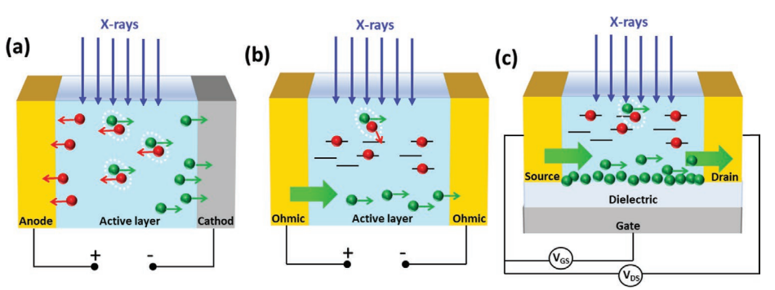

Figure 2.4 Schematics for the direct X-ray detection processes: (**a**) Charge collection in photodiode architecture; (**b**) Photoconductive gain in photoconductor architecture; (**c**) Photoconductive gain in phototransistor architecture (Laura Basiricò A. C., 2021).

For 2D organic semiconductors, the X-ray detection mechanism includes two simultaneous processes (Fig. 2.4). Charge collection was already introduced in Chapter 1 regarding X-ray detectors based on inorganic semiconductors. Similarly for organic semiconductors, when X-ray radiation directly impinges on the active channel, X-ray photons create electron-hole pairs, which are then separated by an applied electric field and thus, additional charge carriers are collected by the electrodes. In order for the charge carriers to reach the collecting electrodes, it is important that the recombination time is sufficiently high and that the density of traps is low. Consequently, charge collection mechanism is dominant for 2D organic semiconductors of high purity and homogeneity (Laura Basiricò A. C., 2021).

The second mechanism introduces *photoconductive gain* (Fig. 2.4 (b,c), Fig. 2.5) and occurs along with the charge collection process. This mechanism amplifies the photogenerated current by the factor *G*, leading to the photo-to-electrical efficiency exceeding 100 % and providing high sensitivity to the X-ray radiation. Photoconductive gain mechanism occurs when radiation-generated, free charge carriers accumulate and pass several times through the semiconductor active channel before recombination sets in. This amplification process is activated by the trapping of minoritycharge carriers during their migration in the semiconductor under the applied field. The factor *G* can be expressed as the ratio between the recombination time *τr* – characteristic of the trap states, and the transit time *τtr* of free moving carriers:

|  |  |
| --- | --- |
|  | 2.11 |

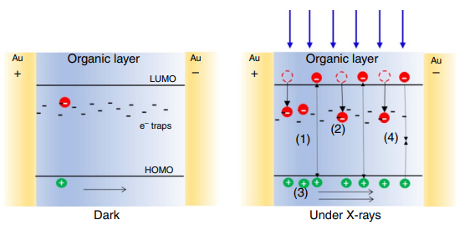where *L* is the channel width, *µ* is the charge carrier mobility and *V* is the applied bias across the active channel. *τr* and *τtr­* represent respectively the time of recombination of the *minority* charge carriers trapped in the active layer, that is, the minority carrier lifetime in a trap, and the transit time of the *majority* carrier to travel across the active channel of the detector (Laura Basiricò A. C., 2021).

Figure 2.5 Schematics of the process of modulation of the conductivity induced by X-rays exposure of TIPS-pentacene thin films: (***left***) in the dark (absence of X-rays) the conductivity is due to the intrinsic carriers; (***right***) under X-ray radiation: (**1**) additional electrons are generated; after generation holes drift along the electric field until they reach the collecting electrode while (**2**) electrons remain trapped in deep trap states withing the organic material. (**3**) To guarantee charge neutrality, holes are continuously emitted from the injecting electrode. AS a consequence, for each electron-hole pair created, more than one hole contributes to the photocurrent leading to the photoconductive gain effect. (**4**) Recombination process takes place, counterbalancing the charge photogeneration in the steady-state (Laura Basiricò A. C., 2016).

The photoconductive gain mechanism has been proposed to interpret high sensitivity in thin-film organic photoconductors based on solution processed bis-(triisopropylsilylethynyl)pentacene (TIPS-pentacene) and derivatives (Laura Basiricò A. C., 2016). As was mentioned in Chapter 1, the cross-section of photoelectric absorption is proportional to , where as well as Compton scattering is linearly proportional to *Z*. As a result, materials with high atomic number *Z* perform more efficient interaction with X-ray photons and therefore, possess high sensitivity. On the other hand, organic thin-film X-ray detectors are based on semiconductors with both low atomic number and interaction volume, which leads to extremely low absorption of X-rays.

Approximately 0.0015 % of incident radiation was absorbed by 100 nm thick TIPS-pentacene films. As a result, due to low photon absorption, the obtained photocurrent was calculated to be pA. At the same time, the observed photocurrent was about two orders of magnitude higher than the theoretical value (Laura Basiricò A. C., 2016). It means that some amplification mechanism must be involved.

Since TIPS-pentacene is a *p*-type semiconductor, a different behaviour can be assumed for photogenerated holes and electrons. Holes drift along the active layer reaching the collecting electrode, while electrons get trapped and act as “doping centers”. Due to the ohmic nature of the electrical contacts, charge neutrality is sustained in the active channel. Therefore, for each hole collected by the electrode, another hole is injected in the channel. As a result, for one electron-hole pair created, more than one hole contributes to the X-ray induced photocurrent before recombination takes place. Such amplification phenomenon results in the photoconductive gain (Laura Basiricò A. C., 2021).

Besides photoconductors, phototransistors based on organic semiconductor thin films have also been demonstrated to detect X-rays with high sensitivity due to enhancement of the photoconductive gain effect through the gate polarization (Fig. 2.3 (c)). As mentioned in the previous section, the gate voltage sweeps to progressively switch on the conductive channel in the transistor, that is, towards more negative/positive values of *VGS* for *p-*type/*n*-type semiconductor, the charge density in the transistor’s active channel increases, leading to the enhancement of minority carriers accumulation and majority carriers conduction. Furthermore, majority charge carriers are more easily injected from the electrodes due to the lowering of the contact resistance. Therefore, in over-threshold condition *τtr* decreases, which leads to the increase of the photoconductive gain *G* (Laura Basiricò A. C., 2021).

## Sensitivity

As was discussed in previous chapters, an X-ray detector’s efficiency performance is determined by numerous parameters, such as the atomic number *Z* of the semiconductor, its band gap energy and bulk resistivity. Nonetheless, from a technological standpoint, our attention below centers on the *sensitivity* of an active channel of a phototransistor. This parameter will further serve as the benchmark for evaluation of the efficiency of our device.

The sensitivity of an X-ray detector is denoted by *S* and characterizes the ability of a detector to react to certain amount of X-ray radiation by generating photocurrent in the active channel. Although there are several formulas describing sensitivity, the basic method to calculate *S* is based on the dependence of photocurrent |*IPH*| on dose rate *DR*. First, one has to measure the photocurrent created by incident X-ray radiation with certain dose rate. Typically, the photocurrent is the difference between the current *IX-ray* across the active channel during X-ray radiation and the current *Idark*, when the radiation is absent. The entity of dose rate is the amount of X-ray radiation energy per unit mass of the absorber material and per unit second of irradiation. Then, once several values of |*IPH*| at different *DR* are obtained, the resulting plot is fitted with linear function. Finally, sensitivity is defined as the slope, or equally, the derivative, of the linear plot (Laura Basiricò A. C., 2021):

|  |  |
| --- | --- |
|  | 2.12 |

However, often it is more convenient to study the sensitivity of a thin-film detector without being tied to the geometry of the active channel and with focusing only of the semiconductor properties. In this case, it is common to calculate sensitivity per unit area or per unit volume of the active channel:

|  |  |
| --- | --- |
|  | 2.13 |

or:

|  |  |
| --- | --- |
|  | 2.14 |

where *A* and *V* are the respectively area and the volume of the active channel. The SI unit of photocurrent is , the SI unit of dose rate is , therefore the SI unit of sensitivity is . For the case of sensitivity per unit area or unit volume, the unit is usually expressed as: , .

It is mentioning that dose rate is inversely proportional to the square of distance from an X-ray source:

|  |  |
| --- | --- |
|  | 2.15 |

Consequently, while using an X-ray source for measuring the sensitivity of a thin-film detector, the dose rate must be properly calibrated accordingly to the distance between the X-ray source and the device. For example, if one knows the dose rate *DR1* at distance *r1* from the source, the dose rate *DR2* at distance *r2* can be calculated as follows:

|  |  |
| --- | --- |
|  | 2.16 |
|  |  |

## Examples of sensitivity of some organic and hybrid semiconductors

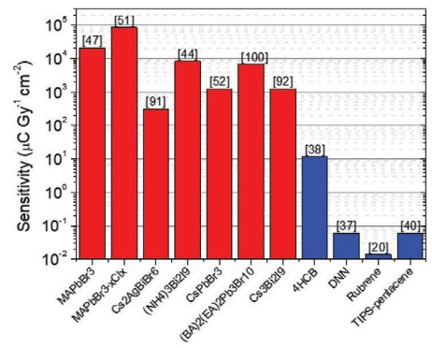

Figure 2.6 Comparison of top sensitivity for organic and perovskite-based detectors (Laura Basiricò A. C., 2021).

To estimate the performance of different thin-film direct X-ray detectors, from large multitude of organic and hybrid semiconductors we will regard several 2D materials that are currently under investigation. When it comes to thin-film photovoltaics, among the most prominent are perovskite-based X-ray detectors. Recent studies on such devices have been primarily concentrated on identifying technological approaches to improve film thickness, specifically radiation absorption, at the same time ensuring a sufficient µτ product to uphold optimal charge collection efficiency. The highest sensitivity reported for a perovskite-based detector was found to be 1.22 × 105 µC/(Gy·cm2) for a 800 µm thick MAPbI3 wafer fabricated by a heating-assisted press method (Laura Basiricò A. C., 2021).

Another example of a direct thin-film organic X-ray detector is based on bis-(triisopropylsilylethynyl)pentacene (TIPS-pentacene) with the photoconductor architecture. The device was fabricated while drop casting onto flexible poly(ethyleneterephtalate) (PET) substrate. While biasing the X-ray detector with 0.2 V, the highest sensitivity value was evaluated as 77 × 103 nC/(mGy·cm3) (Laura Basiricò A. C., 2016). On the other hand, in (Inés Temiño, 2020), TIPS-pentacene organic field effect transistors (OFETs) were used as X-ray detectors and exhibited the record sensitivity of 1.3 × 104 µC/(Gy × cm2) while being biased at *VSD* = -20 V and *VGS* = -15 V exposed to a dose rate of 53 mGy/s.

Regarding hybrid semiconductors, in (H.M. Thirimanne, 2018) a thin-film direct X-ray detector with the photodiode architecture was made of hybrid semiconductor consisting of organic bulk heterojunction (BHJ) of poly(3-hexylthiophene-2,5-diyl) (P3HT) and [6,6]-Phenyl C71­ butyric acid methyl ester (PC70BM), with the nanoparticles (NPs) of Bi2O3. The X-ray source was a medical linear accelerator. The sensitivity of such devices was estimated to be 1712 µC/(mGy × cm3) under 50kV soft X-rays and ~30 and 58 µC/(mGy × cm3) under 6 and 15 MV hard X-rays. The sensitivities were obtained at -10 V applied to the photodiode.

## Overview on X-ray detectors based on TMTES:PS

In the previous work regarding X-ray detectors in the form of *p*-type OFETs based on TIPS-pentacene blended with polysterene (PS), the devices already demonstrated excellent sensitivity comparable to the perovskite-based detectors. The organic semiconductor (OSC) thin films were fabricated by the solution shearing technique of high processing capacity, known as the *bar-assisted meniscus shearing* (BAMS) method, which outputs large scale crystalline films. During the analysis, it was concluded that the organic-based detector efficiency strongly depends on the grain size and grain boundaries and also on the mobility of the active channel. Regarding the former in combination with photoconductive gain mechanism, films with smaller crystal domains exhibited better performance due to increase of the density of traps for minority charge carriers (in case of TIPS-pentacene electrons are the minority carriers), which enhanced photoconductive gain and thus, sensitivity. At the same time, the active channel mobility can be improved by employing the OSCs with crystal structure containing strong intermolecular electron coupling and by reducing the density of traps for the majority charge carriers (for TIPS-pentacene, holes are the majority carriers). The density can be decreased by using OSC:PS blends, as thin film deposition induces vertical phase separation, creating a lower PS layer that passivates the interfacial majority carriers traps and again, enhances the majority charge carrier mobility also contributing to the sensitivity (Laura Basiricò A. C., 2016), (Adriàn Tamayo, 2022).

In an effort to enhance the performance of the X-ray detector, the focus shifted towards producing OFETs with improved hole transport. For this purpose, a similar *p-*type OSC 1,4,8,11-tetramethyl-6,13-triethylsilylethynyl pentacene (TMTES) blended with PS was analyzed. The molecular structure of TMTES closely resembles that of TIPS-pentacene. Nevertheless, thin films of TMTES deposited with the BAMS method resulted in completely different crystal packing arrangement, characterized by a herringbone packing motif. As a result, the density of traps was reduced due to the PS layer, which led to the enhancement of the mobility up to 2.5 cm2/(V·s). The new device performed outstanding sensitivity of (4.5 ± 0.05) × 1010 µC/(Gy · cm3), which exceeded that of TIPS-pentacene detector by one order of magnitude. Consequently, the sensitivity of the TMTES:PS device was reported to be the highest of a fully organic X-ray detector (Adriàn Tamayo, 2022).

|  |  |
| --- | --- |
| **(a)** | **(b)** |
|  |  |

Figure 2.7 (**a**) Molecular structure of TMTES and PS; (**b**) Schematics of the BAMS technique for the deposition of the active layer (Laura Basiricò A. C., 2016).

Since the experimental part of our research regarding TMTES:PS X-ray detectors will be also compared to the results from this work (Laura Basiricò A. C., 2016), it is important to transmit more in detail the conditions in which the TMTES:PS based devices were characterized. Ambient conditions were sustained during the thin film deposition by BAMS. It was found that the use of combination of small molecule OSCs blended with insulating polymers can ease the solution processability resulting in thin films with improved electrical performance and device stability. The selection of PS as a binding polymer was based on its low relative permittivity, good solubility in organic solvents, cost-effectiveness and its weak interaction with organic semiconductors. Different ratios between TMTES and PS were considered during the TMTES:PS thin film preparation. As a result, the finest thin film properties were attained by using a 2:1 ratio of TMTES to PS (PS with a molecular weight of 280 KDa). The solution was deposited at 105 ℃ on Si/SiO2 substrates with interdigitated Au electrodes treated with a self-assembled monolayer of 2,3,4,5,6-pentafluorobenzenethiol (PFBT). The thickness of the TMTES:PS films was estimated as 32±7 nm (Adriàn Tamayo, 2022).

In order to view the chemical map of the TMTES:PS thin films, Time-of-Flight Secondary Ion Mass Spectroscopy (ToF-SIMS) was applied for both horizontal and vertical dimensions. As a result, no horizontal phase separation was observed. At the same time, during vertical profiling, the signal from TMTES notably decreased, whereas the PS ion signal increased, exhibiting larger concentration of PS molecules closer to the SiO­2 substrate (Adriàn Tamayo, 2022).

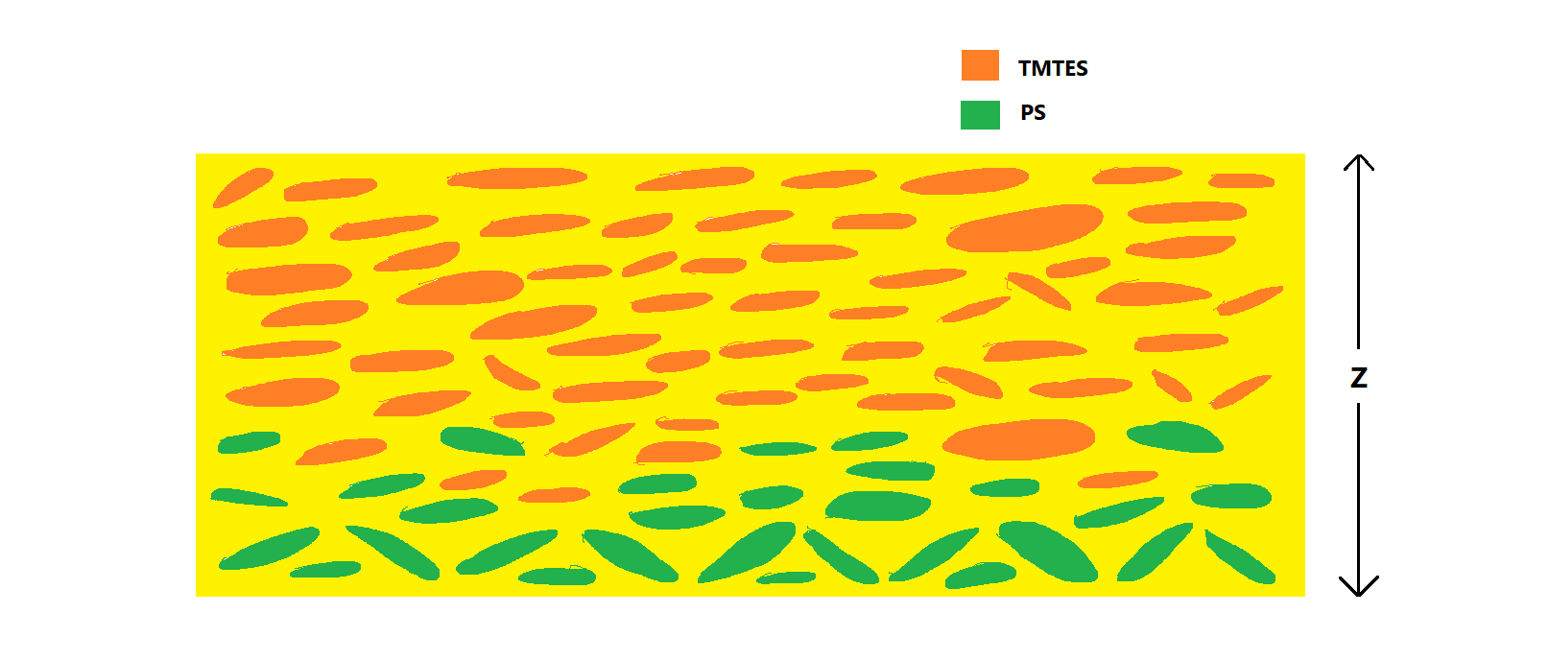

Figure 2.8 Vertical cross-section of a TMTES:PS thin film. PS molecules (green) are concentrated at the bottom, while TMTES (orange) are located in the top part of the film.

Both TMTES and TMTES:PS thin films underwent electrical characterization under ambient conditions as active layers in OFETs. As a result, OFETs with TMTES:PS as the active layer exhibited better performance compared to those based solely on TMTES. The former operated within a lower voltage window of 5 V and displayed excellent electrical characteristics with reduced hysteresis and significantly less dependence of the mobility on *VGS*. The threshold voltage *VTH* for TMTES:PS based devices approached 0 V (ranging from -0.5 to -1 V), providing further evidence of benefit of using PS together with the semiconductor. Additionally, the density of traps for the majority charge carriers (in this case holes), was estimated from the sub-threshold slope to be (3.9±0.9) × 1011 e/(V·cm2), which is one order of magnitude lower than that for the TMTES films (~1012 e/(V·cm2)). This observation confirms that adding the insulting PS to TMTES compound results in reduction of interfacial traps for majority charge carriers (Adriàn Tamayo, 2022).

Finally, detectors based on TMTES:PS exhibited a notably high average mobility of 2.6 ± 0.6 cm2/(V·s) with the maximum value of 3.1 cm2/(V·s). Such mobility values in combination with previously mentioned electrical characteristics of TMTES:PS thin films rank among the best reported for this semiconductor. It is noteworthy that the films were fabricated using a low-cost and high throughput BAMS technique which is a significant advantage in terms of mass production (Adriàn Tamayo, 2022).

Such remarkable electrical properties of TMTES:PS based OFETs deposited by the BAMS technique allowed to presume these devices to perform efficiently as X-ray detectors. For this purpose, the sensitivity of the TMTES:PS based OFETs was measured under X-ray radiation in the form of periodic pulses (on/off beam switches) of different dose rate. During the X-ray exposure, the

|  |  |  |
| --- | --- | --- |
| **(a)** | **(b)** | |
| **(c)** | |  |

Figure 2.9 Electrical and X-ray performance of the TMTES:PS based OFETs. (**a**) Transfer characteristics in saturation regime; (**b**) output characteristics; (**c**) X-ray induced photocurrent as a function of the dose rate. The sensitivity is calculated as the slope of the linear fit of the experimental points (Adriàn Tamayo, 2022).

devices biased to operate in saturation regime (*VDS* = -15 V and *VGS* = -20 V). The current *IDS* flowing between the source and drain was measured during the on/off beam switching cycles. The photocurrent was measured as the difference between the values of *IDS* during X-ray radiation and in the dark. The resulting signal was amplified by the photoconductive gain effect (discussed in previous sections), which occurs due to minority carriers traps and which allows low-Z thin-film organic semiconductors to perform high sensitivity. According to its definition, the sensitivity of TMTES:PS based OFETs was calculated as the slope of the linear fit to the dependence of the photocurrent |*IPH*| on the X-ray dose rate. Resultantly, the sensitivity of the TMTES:PS based detectors was estimated as (4.10 ± 0.05) × 1010 µC/(Gy·cm3). Such value was considered as the highest sensitivity value documented for an X-ray detector based on fully organic active layer, which also surpassed the sensitivity of the majority of the sensors based on perovskite films. Additional advantage of the TMTES:PS based detectors in comparison with those based on lead-halide perovskites, is that it fully matches human tissue equivalent absorbance of ionizing radiation. This feature paves the way for TMTES:PS based X-ray imaging detectors in numerous medical dosimetry applications (Adriàn Tamayo, 2022).

Such remarkable sensitivity of TMTES:PS based X-ray detectors in combination with their outstanding electrical properties and tissue-like absorbing behaviour inevitably consider further research into this new technology. For this purpose, the second part of my experimental study includes both electrical characterization and performance under radiation of OFETs with the active layer made of TMTES:PS with different ratio of TMTES to PS. The goal of my laboratory study is to trace any dependence of the device performance on the TMTES:PS ratio and to provide scrupulous and comprehensive analysis on this tendency. The most part of the study has already been conducted by my colleague Alessandro Galeazzi, therefore, his results will be directly connected to my research. Additionally, it is noteworthy to mention that the TMTES:PS based OFETs were equally fabricated at the Institute of Materials Science of Barcelona (ICMAB) in the research group of Dr. Marta Mas-Torrent. Therefore, the information of the materials and device fabrication, which was referenced in this overview, shall be duplicated in the Chapter 3. Nevertheless, such repetitiveness should not only provide consistency in the persistent and comprehensive research on TMTES:PS based X-ray detectors, but also introduce new details on their structure and production procedure.

## Overview on TMDC

Alongside with detectors based on fully organic semiconductors, recently great attention has been drawn by 2D transition metal dichalcogenides (TMDCs) in the thin-film optoelectronics field as prominent materials for *in vivo* radiation monitoring applications. TMDCs compose a large class of inorganic layered materials, which perform a variety of different electronic properties from semiconductivity to superconductivity, which makes TMDCs quite perspective materials for nanoelectronics, thin-film flexible electronics and power conversion domain (Arun Kumar Singh, 2018), (Alberto Taffelli, 2023).

TMDCs have the **MX2** stoichiometry, where M stands for a transition metal (M = Mo, W, Ti, Nb etc.) and X means a chalcogen (X = S, Se, Te etc.). The general structure of a TMDC represents a sandwich-layer structure, in which a layer of transition metal atoms is placed between two layers of hexagonally packed chalcogen atoms, thus, forming a periodic **X-M-X** layer order (Fig. 2.6). The bulk crystal of TMDC consists of the X-M-X layers bound together with weak van der Waals forces. (Arun Kumar Singh, 2018), (Saju Joseph, 2023).

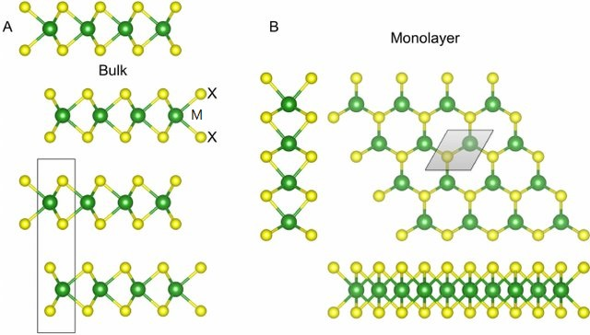

Figure 2.10 The atomic structure of TMDCs of 2H polytype. M stands for a transition metal, X signifies chalcogenide). Bulk (**A**) and monolayer (**B**) structures are demonstrated with their unit cells. Layers are bound together by van der Waals forces (Heine, 2015).

Among the diverse multitude of different TMDC compounds, our attention shall now focus on **MoS2**, which is particularly attractive for the field of thin-film electronics. The crystal structure of MoS2 can be categorized into four polytypes, depending on the atomic stacking configurations: 1H, 1T, 2H and 3R (Fig. 2.7). The 2H-polytype is thermodynamically favoured by naturally occurring bulk MoS2 and represents the S-Mo-S layers stacked in hexagonal symmetry (from the top view) with each Mo atom covalently bonded with neighbouring six S atoms (Arun Kumar Singh, 2018). In contrast, in the 1T-polytype, which is metastable (Mattevi, 2020), forms a tetragonal symmetry with an octahedral metal coordination, as the layers are offset from each other. The 2H-MoS2 structure exhibits semiconducting properties, whereas the 1T-MoS2 is metallic. The metastable 1T-MoS2 can be readily transformed to 2H phase via intralayer atomic gliding under specific conditions (Arun Kumar Singh, 2018) (1T-Phase Transition Metal Dichalcogenides (MoS2, 2017).

### Electrical properties of monolayer MoS2

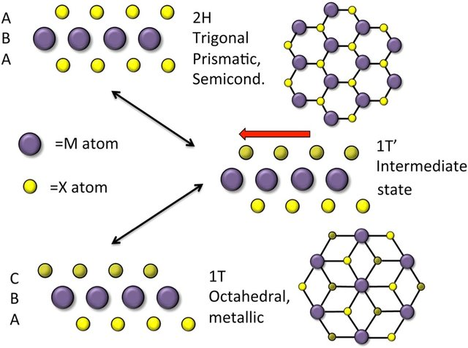

Figure 2.11 Schematics of the 2H- and 1T-polytypes of MoS2. the 2H phase is trigonal prismatic and the material behaves as a semiconductor. The 1T phase is octahedral and the material is metallic. The 1T’ phase represents an intermediate state (Adam L. Friedman, 2017).

Recent progress in the characterization of nanoscale materials has created new possibilities to thoroughly study the electrical and optical properties of 2D TMDCs by means of computational modelling tools. Utilizing the first-principle density functional theory (DFT), it has become possible to calculate the band structure of MoS2 both as bulk and as a monolayer (Fig. 2.8). As a result, it was

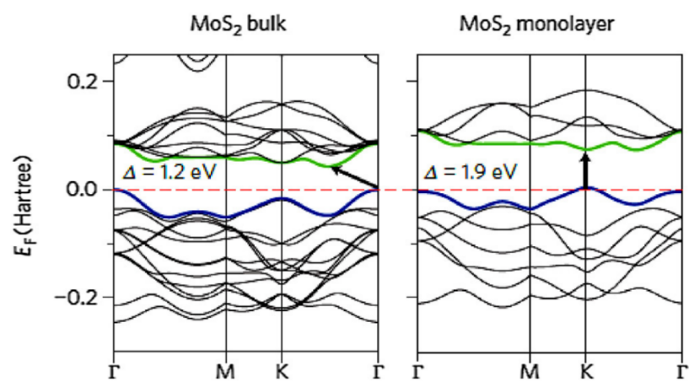

Figure 2.12 Band structures for bulk and monolayer MoS2 calculated with the first-principles DFT. The pointer indicates the band gap (direct for monolayer and indirect for the bulk), the red dashed lines indicate the Fermi level. The top of the valence band and the bottom of the conduction band are highlighted in blue and green, respectively (Arun Kumar Singh, 2018).

revealed that the MoS2 crystal possesses an indirect band gap of 1.9 eV at the Г-point. While decreasing the number of layers for MoS2, the band gap energy gradually decreases, thus, in a monolayer MoS2 the band gap is direct has the value of 1.2 eV.

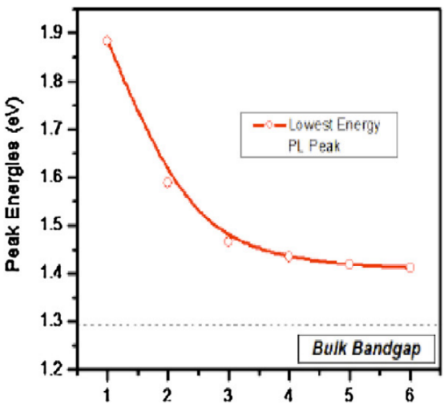

Figure 2.13 Band gap energy of MoS2 as a function of layers. the dashed line shows the (indirect) band gap energy of bulk MoS2 (Arun Kumar Singh, 2018).

The semiconductor-like behaviour of MoS2 subsequently led to its testing in FETs as an active channel. As a result, recent research has evaluated the main electrical parameters of a top-gate FET based on monolayer MoS2 in ambient conditions. The device performed the *n*-type behaviour with the average mobility exceeding 200 cm2/(V·s), the ON/OFF ratio of ~108 and the subthreshold swing (*SS*) of 74 mV/dec (Arun Kumar Singh, 2018). Such excellent electrical properties in combination with suitable mechanical flexibility eventually introduce monolayer MoS2 (1L-MoS2) as a prominent semiconductor for usage in thin-film flexible electronics including also detectors for ionizing radiation.

Another example of employing MoS2 thin films in FETs is presented in (Ji Heon Kim, 2016). In this research Thin MoS2 flakes with different number of layers (*Nlayer* = 1, 3 and 6) were fabricated by mechanical exfoliation (see below) and then transferred onto highly *n*-doped silicon wafers with SiO2 dielectric on top. The IV-characterization was performed in ambient conditions. As a result, the average subthreshold swing *SS* was found to be 0.92, 0.92 and 1.41 V/dec for 1L-, 3L- and 6L-MoS2, respectively. The ON/OFF ratio was calculated as ~107 for all the transistors. Finally, the field-effect electron mobility *µ* increased with increasing of *Nlayer* ranging from ~10 to 18 cm2/(V·s) (Ji Heon Kim, 2016).

Performance of monolayer MoS2 in FETs was also verified in (Zongyou Yin, 2011). In this work 1L-MoS2 nanosheet was equally fabricated by mechanical exfoliation and deposited onto a Si wafer. According to the results, the ON/OFF ratio was found to be ~ 103, whereas the calculated field-effect mobility of was 0.11 cm2/(V·s).

|  |  |
| --- | --- |
|  | **(c)** |

Figure 2.14 (**a**) Schematic cross-section of a MoS2 thin-film transistor with bottom-gate architecture; (**b**) optical micrograph of the representative MoS2 transistor; (**c**) field-effect mobility of the MoS2 FET as a function of Nlayer (Ji Heon Kim, 2016).

### Fabrication methods of 1L-MoS2

Before discussing the role of 1L-MoS2 as an active layer in X-ray detector, it is of good practice to first regard different fabrication methods of the monolayer, which typically include mechanical exfoliation, chemical vapour deposition, RF sputtering and various liquid phase preparations. The mechanical exfoliation (ME) technology involves the “peeling” or “cleaving” of bulk crystals by using an adhesive tape or rubbing the crystals against a solid surface. as a top-down technique, ME has been widely applied to produce single- or few-layer MoS2 (and TMDCs in general) thin films from their bulk counterparts. As previously mentioned, in TMDCs layers are bonded together along the vertical axis with weak van der Waals forces, which allows to perform easy exfoliation due to weak interlayer forces. Consequently, the ME technique can be used to produce a few-layer MoS2 film with thickness of approximately 3-10 nm. Nevertheless, while ME enables the fabrication of clean and high-quality MoS2 thin films, this method is limited to research purposes only is not applicable to large-scale production (Arun Kumar Singh, 2018).

* **Exfoliation method**

Beside the mechanical method, a thermally activated metal-mediated exfoliation method is available. The fundamental concept behind this exfoliation technique lies in the cleaving a parent MoS2 crystal onto a metal surface by overcoming van der Waals interlayer forces, such that the bottom layer will remain on the surface through MoS2-metal interaction. Gold (Au) has proven to be highly effective in exfoliating layered materials including TMDCs by gold affinity towards chalcogen-based compounds (Max Heyl E. J.-K., 2022). The illustrated process of thermally activated metal-mediated process is depicted in Fig.2.10, utilizing MoS2 as the test material. The exfoliation initiates by exposing MoS2 and Au surfaces, bringing them together on a hotplate. The process concludes by peeling off the MoS2 parent crystal, resulting in large-area MoS2 layers exfoliated onto gold. The annealing step is normally conducted at 200 ℃, while performing output of worse quality at lower temperatures (Max Heyl D. B.-K., 2020).

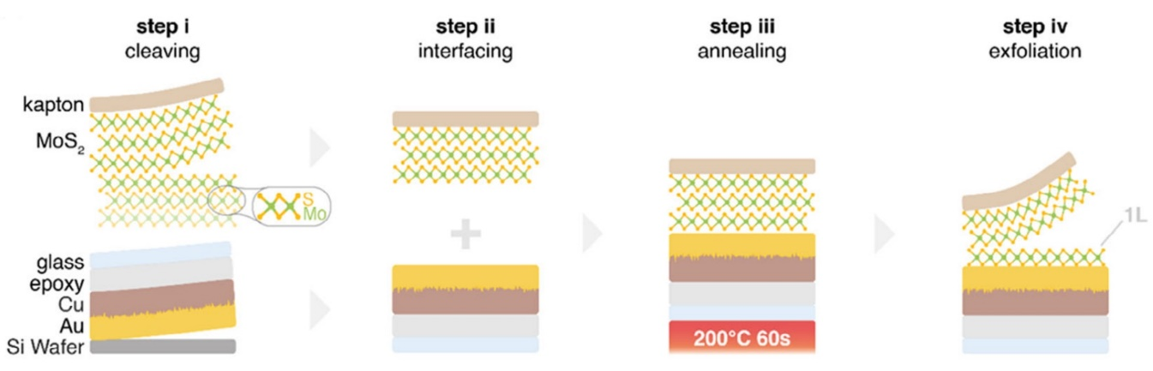

Figure 2.14 Schematic illustration of thermally activated metal-mediated exfoliation process of a MoS2 thin film on a Au surface (Max Heyl D. B.-K., 2020).

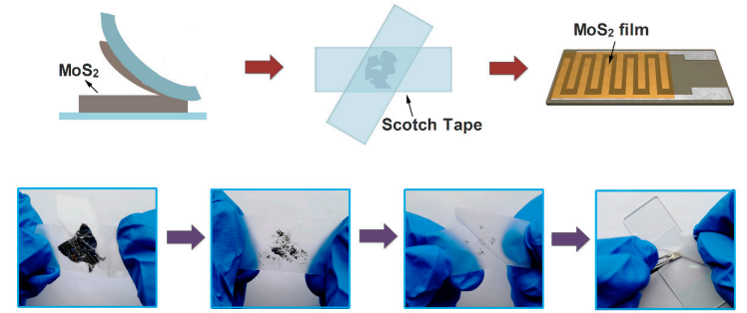

Figure 2.15 Schematic representation of the fabrication of MoS2 thin films by mechanical exfoliation (with the use of a scotch tape) (Wenli Li, 2019).

Often the resulting MoS­2 thin film is produced in the form of flakes with the area of a few mm2, as it was in my experimental research. For example, I was given MoS2-based phototransistors with the active channel in the form of a flake with the drain and source electrodes attached to it. And basically, it would not disturb the characterization of the detectors based on such flakes in laboratory conditions. However, because of weak attachment between the flake and a substrate, the mechanical exfoliation imposes a risk to lose or damage MoS2 flakes while moving the substrate or rotating it during an experiment. Therefore, it is vital to treat the samples with ME-fabricated MoS2 nanosheets with great carefulness.

* **Chemical Vapour Deposition (CVD) method**

As we see, although mechanical exfoliation represents quite reliable and easy-to-perform method of TMDC thin film deposition, it loses all its potential when it comes to mass production and real-world applications. In this, case, an alternative deposition technique should be used to output large-scale TMDCs nanosheets. Chemical vapour deposition (CVD) stands out as a good candidate for this purpose, as it has been widely adopted for the mass production of devices based on III-V and III-N materials. Despite its apparent simplicity, this technique continues to be one of the most extensively utilized methods for synthesizing thin films of TMDCs and in particularly, of MoS2. Numerous positive reviews on the applying of the CVD method relatively to MoS2 have already been published, which promotes the further research on this fabrication technique (Luca Seravalli, 2021).

The working principle of CVD is depicted on Fig. 2.16. Precursors, consisting of either only S or both S and Mo, are delivered in gaseous form to a substrate, which is maintained at high temperature. At this temperature, the necessary chemical mechanisms for MoS2 deposition onto the substrate takes place. While the substrate is typically held in horizontal position in most reports, it usually suffers from the film thickness gradient along the direction of the flow, leading to non-uniform deposition and challenges in determining the growth parameters of the film. To overcome this issue, the development of vertical CVD reactors takes place, since this configuration allows for easier control and homogeneity of temperature and precursor throughout the substrate surface (Luca Seravalli, 2021).

A common procedure starts with the reduction of contamination from external air and O2 within the CVD tube by purging the system with inert gas multiple times before initiating the growth process. A typical CVD process depends on the phase form of the used precursors (solid, liquid or gaseous) and can be roughly divided in to the following steps: (1) converting the precursors (Mo and S) into a gaseous state and absorbing them into the inert carrier gas by evaporation or as sublimation powders; (2) transporting the reactive species using the carrier gas to reach the substrate; (3) Diffusing the precursors toward the substrate surface; (4) Adsorption of the precursors at the surface, leading to the synthesis of the MoS2 thin film (Luca Seravalli, 2021).

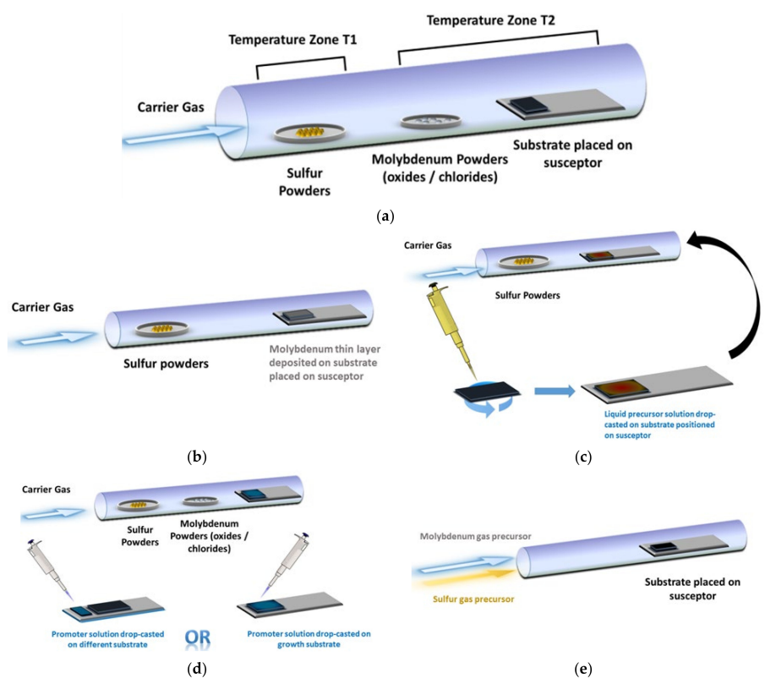

Figure 2.16 Schematic representation of the CVD tube in different configurations for MoS2 thin film growth: (**a**) with solid precursors separated from each other; (**b**) with solid Mo precursor deposited on the substrate in advance; (**c**) with liquid Mo precursor deposited on the substrate; (**d**) with solid precursors and drop-casted promoters (either on the growth substrate or on a different substrate); (**e**) with gaseous precursors (Luca Seravalli, 2021).

In the standard horizontal setup, a quartz tube with dimensions of approximately 1 m in length and a diameter of 2-5 cm is employed. Heating is achieved through a resistor element wrapped around the tube. The MoS2 deposition process requires the temperature in the range of 600-800 ℃. In certain instances, an additional heating zone in the range of 100-200 ℃ is required for the S precursor. For improved reproducibility and control, it is more convenient to independently heat this supplementary zone, where the S precursor is initially located. Alternatively, it is feasible to directly deposit the Mo precursor onto the substrate, either in solid form or as a liquid solution. Growth promoters may be added on the growth substrate or on a separate substrate to enhance the processibility. Lastly, the use of gaseous precursors eliminates the need to place the precursors inside the tube before initiating the process (Luca Seravalli, 2021).

### Overview on the performance of 1L-MoS2 direct X-ray detectors

The mechanical exfoliation and CVD methods are only a few examples of the fabrication techniques for MoS2 thin films. Such sophisticated, yet crucial, production process deserves much more comprehensive discussion, however, the analysis would draw exceedingly large attention from the main objective of this section. The main idea still sticks to the perspective of using the MoS2 thin films for X-ray detection. Since, as already mentioned, there has not been much research on usage of MoS2 specifically for X-ray sensing, only a few of reports could provide any data about the sensitivity of MoS2-based detectors. Regarding concretely my research, the part concerning the characterization of 1L-MoS2 X-ray detectors was motivated by their excellent performance previously reported in the work of Taffelli *et al* (Alberto Taffelli, 2023). My objective was to thoroughly examine phototransistors based on 1L-MoS­2 thin films to verify if they exhibit sensitivity higher than that of the organic X-ray detectors, in particular, of the TMTES:PS based sensors.

Therefore, since the results from my work concerning the 1L-MoS2 X-ray detectors will be inseparably related to the data from Taffelli *et al.*, it is important to introduce beforehand their research and its outcome.

The goal of the research group was to showcase the effective usage of thin-film MoS2 as a potential semiconducting material for direct X-ray detection. For this purpose, the group constructed a planar detector based on the photoconductor architecture, utilizing a monolayer MoS2 (1L-MoS2) as an active layer. The device was exposed to X-rays within the energy range of 10-100 keV. Furthermore, to enhance the detector photoresponse to X-rays, a scintillator film was employed to induce light-matter interaction in the visible light spectrum. This strategy led to a threshold increase in photocurrent by converting a fraction of the radiation into the visible spectrum.

The 1L-MoS2 thin films were fabricated with the exfoliation of a MoS2 bulk crystal through a thermally activated metal-mediated process. With this process, 1L-MoS2 was acquired on a thin Au film. After that a monolayer MoS2 film was then covered with a polystyrene film of ~1 µm via spin coating. The gold film was then etched leaving the MoS2 monolayer embedded in PS, which was then transported to the substrate through wet transfer. The resulting X-ray detector was constructed on a soda-lime glass substrate, where gold (Au) electrodes with the thickness of 100 nm were deposited via thermal evaporation. The active channel was created by the MoS2 and was supposed to have the area of 1×0.3 mm2 determined by the area between the collecting electrodes. The thickness of the active channel was evaluated as 0.9 nm. The scintillator film with the thickness of 0.2 nm, was based on polydimethylsiloxane (PDMS) containing gadolinium oxysulphide doped with terbium (Gd2O2S:Tb) and was deposited on top of the PS film, thus, resulting in the layered structure depicted in Fig. 2.12 (Alberto Taffelli, 2023).

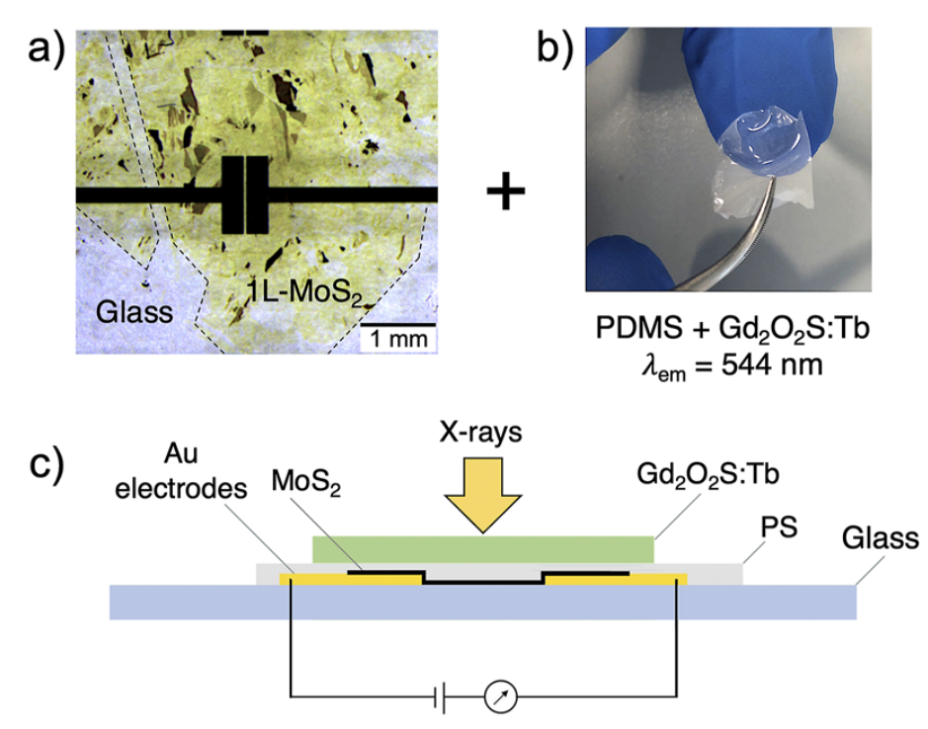

Figure 2.17 (**a**) An optical image taken with a microscope of the top view of the X-ray detector device based on 1L-MoS2. The dashed line outlines the MoS­2 flake, under which the Au electrodes are deposited; (**b**) An image of the scintillator film based on PDMS and loaded with Gd2O2S:Tb; (**c**) A schematic cross-section of the 1L-MoS2-based X-ray detector (Alberto Taffelli, 2023).

The fabricated MoS2 detector then underwent X-ray testing to test its sensitivity under direct radiation. The active channel was constantly biased under *Vbias* = 5 V. The X-rays were generated by a tungsten anode (*WKα* = 59 keV) operated at peak voltages of 40, 100, 150, 195 kV filtered with 3 mm of copper. The radiation was generated in the form of periodic pulses of 20 s in the *on*-regime and 40 s in the *off*-regime. The X-ray response of the MoS2 detector was measured both with and without the scintillator film placed on top of the detector. The PS layer on top of MoS2 was estimated to absorb less than 0.01 % of the incident radiation, therefore, it was not supposed to deteriorate the obtained data from the active channel (Alberto Taffelli, 2023).

Consequently, the photoresponse exhibited an increase of up to three times when incorporating the scintillator film onto the detector. The amplification was ascribed to the generation of additional visible photon from the scintillator through indirect X-ray photoconversion. Furthermore, the MoS­2 detector consistently demonstrated a photoresponse to incoming X-rays over subsequent irradiation cycles, which indicated the reproducibility of the measurements (Alberto Taffelli, 2023).

As a result, the sensitivity per unit volume was evaluated to be within the range of 108-109 µC/(Gy·cm3) with the maximum value of 2.3 × 109 µC/(Gy·cm3). The sensitivity per unit area was estimated to be in the order of 10-100 µC/(Gy·cm3) (Alberto Taffelli, 2023).

According to these numbers, we can conclude that TMDCs, in particular, monolayer MoS2, can be competitive (in relation to fully-organic based) semiconductors for thin-film flexible sensing electronics. Even though TMDCs have not yet been so rigorously studied as organic-based X-ray detectors, it is evident that MoS2-based X-ray detectors are among realizable alternatives to conventional inorganic sensing devices. For this purpose, the first part of my research was the characterization of thin film MoS­2-based X-ray detectors in the form of a phototransistor. The final goal of this study was the estimation of their sensitivity and overall performance.

In the next chapter I shall describe the full process of the experimental part, including also the methods of fabrication of the devices. and the instruments used during the research.

# Experimental Methods

## MoS2 Samples

### Fabrication methods

### IV characterization

### Characterization under X-rays

## TMTES:PS Samples

### Fabrication methods

### IV characterization

### Characterization under X-rays

# Results for MoS2­ samples

# Results for TMTES:PS samples

# Conclusions

# Bibliography

1T-Phase Transition Metal Dichalcogenides (MoS2, M. W.-G.-B. (2017). Nasuha Rohaizad, Carmen C. Mayorga-Martinez, Zdenel Sofer and Martin Pumera. *Applied Materials & Interfaces*.

(2024, February 05). Retrieved from WOLFMET: https://www.wolfmet.com/tungstenalloys

A. Datta, Z. Z. (2020). A new generation of direct X-ray detectors for medical and synchrotron imaging applications. *Scientific Reports*.

Adam L. Friedman, A. T. (2017). Evidence for Chemical Vapor Induced 2H to 1T Phase Transition in MoX2 (X=Se, S) Transition Metal Dichalcogenide Films. *Scientific Reports*.

Adriàn Tamayo, I. F.-T. (2022). X-ray Detectors With Ultrahigh Sensitivity Employing High Performance Transistors Based on a Fully Organic Small Molecule Semiconductor/Polymer Blend Active Layer. *Advanced Electronic Materials*.

al., S. B. (2021). Electrical characterization of 2D materials-based field-effect transistors. *2D Mater.*

al., S. P. (2020). Production of X-RAYS using X-RAY Tube. *Journal of Physics: Conference Series*.

Alberto Taffelli, M. H.-K. (2023, August 1). Demonstrating the high sensitivity of MoS2 monolayers in direct X-ray detectors. *APL Materials*. doi:https://doi.org/10.1063/5.0151794

Arun Kumar Singh, P. K. (2018). 2D layered transition metal dichalcogenides (MoS2): Synthesis, applications and theoretical aspects. *Applied Materials Today*, 242-270.

Ben Depuydt, A. T. (2006). Germanium: From the first application of Czochralski crystal growth to large diameter dislocation-free wafers. In *Materials Science in Semiconductor Processing* (pp. 437-443).

Christian W. Fabjan, H. S. (2020). *Particle Physics Reference Library, Volume 2: Detectors for Particles and Radiation.* Vienna, Austria: Springer.

David Pennicard, B. P. (2017). Semiconductor materials for X-ray detectors. *MRS Bulletin*.

G. Lioliou, A. B. (2016). Gallium Arsenide detectors for X-ray and electron (beta particle) spectroscopy. *Nuclear Instruments and Methods in Physics Reasearch A*, 37-45.

H.M. Thirimanne, K. J. (2018). High sensitivity organic inorganic hybrid X-ray detectors with direct transduction and broadband response. *Nature Communications*. doi:10.1038/s41467-018-05301-6

Heine, A. K. (2015). On the Stability and Electronic Structure of Transition-Metal Dichalcogenide Monolayer Alloys Mo1−xXxS2−ySey with X = W, Nb. *Electronics*.

Inés Temiño, L. B.-T. (2020). Morphology and mobility as tools to control and unprecedentedly enhance X-ray sensitivity in organic thin-films. *Nature Communications*. doi:https://doi.org/10.1038/s41467-020-15974-7

Ji Heon Kim, T. H. (2016). Thickness-dependent electron mobility of single and few-layer MoS2 thin-film transistors. *AIP Adnvances*.

Kittel, C. (2005). Introduction to Solid State Physics, Eighth Edition. John Wiley & Sons, Inc.

Knoll, G. F. (2010). *Radiation detection and measurement; 4th ed.* New York, NY: Wiley.

L. Abbene, f. P. (2019). Room-temperature X-ray response of cadmium-zinc-telluride pixel detectors grown by the vertical Bridgman technique. *Journal of synchrotron radiation*.

L. Abbene, S. D. (2014). CdTe Detectors. In *Comprehensive Biomedical Physics* (pp. 285-314). Elseiver .

Laura Basiricò, A. C. (2016). Direct X-ray Photoconversion in flexible organic thin film devices operated below 1 V. *Nature Communications*.

Laura Basiricò, A. C. (2021). Solution-Grown Organic and Perovskite X-Ray Detectors: A New Paradigm for the Direct Detection of Ionizing Radiation. *Adv. Mater. Technol.*

Luca Seravalli, M. B. (2021). A Review on Chemical Vapour Deposition of Two-Dimensional MoS2 Flakes. *Materials*.

Luisa Torsi, M. M. (2013). Organic field-effect transistor sensors: a tutorial review. *Chem. Soc. Rev.* doi:10.1039/c3cs60127g

M. Schieber, T. S. (2002). Study of impurity segregation, crystallinity and detector performance of melt-grown cadmium zinc telluride crystals. *Journal of Crystal Growth*, 2082-2090.

Mattevi, M. S. (2020). Direct synthesis of metastable phases of 2D transition metal dichalcogenides . *Chem. Soc. Rev.* , 49.

Matthew D. McCluskey, E. E. (2018). Dopants and defects in semiconductors, Second Edition. CRC Press.

Max Heyl, D. B.-K. (2020). Thermally Activated Gold-Mediated Transition Metal Dichalcogenide Exfoliation and a Unique Gold-Mediated Transfer. *hys. Status Solidi RRL*. doi:https://doi.org/10.1002/pssr.202000408

Max Heyl, E. J.-K. (2022). Only gold can pull thiss off: mechanical exfoliations of transition metal dichalcogenides beyond scotch tape. *Applied Physics A*. doi:https://doi.org/10.1007/s00339-022-06297-z

Neamen, D. A. (2012). Semiconductor Physics and Devices: Basic Principles, Fourth Edition.

S. Tsigaridas, S. Z. (2021). Fabrication of Small-Pixel CdZnTe Sensors and Characterization with X-rays. *Sensors*.

S.M. Sze, K. K. (2007). *Physics of Semiconductor Devices, Third Edition.* John Wiley & Sons, Inc.

Saju Joseph, J. M. (2023). A review of the synthesis, properties, and applications of 2D transition metal dichalcogenides and their heterostructures. *Materials Chemistry and Physics*. doi:https://doi.org/10.1016/j.matchemphys.2023.127332

Seibert, J. A. (204). X-ray imaging physics for nuclear medicine technologists. Part 1: Basic principles of x-ray production. *Nuclear Medicine Technology*.

*Silicon Sensors*. (n.d.). Retrieved from DECTRIS: https://www.dectris.com/en/technology/sensors/silicon-sensors/

Technologies, O. I.-r. (2024, February 05). *Managing the Heat Produced by X-ray Tubes*. Retrieved from https://xray.oxinst.com/learning/view/article/managing-the-heat-produced-by-x-ray-tubes

Vetter, K. (2007). Recent Developments in the Fabrication and Operation of Germanium Detectors.

Wenli Li, Y. Z. (2019). Gas Sensors Based on Mechanically Exfoliated MoS2 Nanoshhets for Room-Temperature NO2 Detection. *Sensors*. doi:http://dx.doi.org/10.3390/s19092123

*X-ray Production, Tubes, and Generators*. (n.d.). Retrieved from Radiology Key: https://radiologykey.com/x-ray-production-tubes-and-generators

Yun Sun, P. L. (2022). Key factors for ultra-high on/off ratio thin-film transistors using as-grown carbon nanotube networks. *RCS Advances*.

Zongyou Yin, H. L. (2011). Singe-Layer MoS2 Phototransistors. *American Chemical Society*.